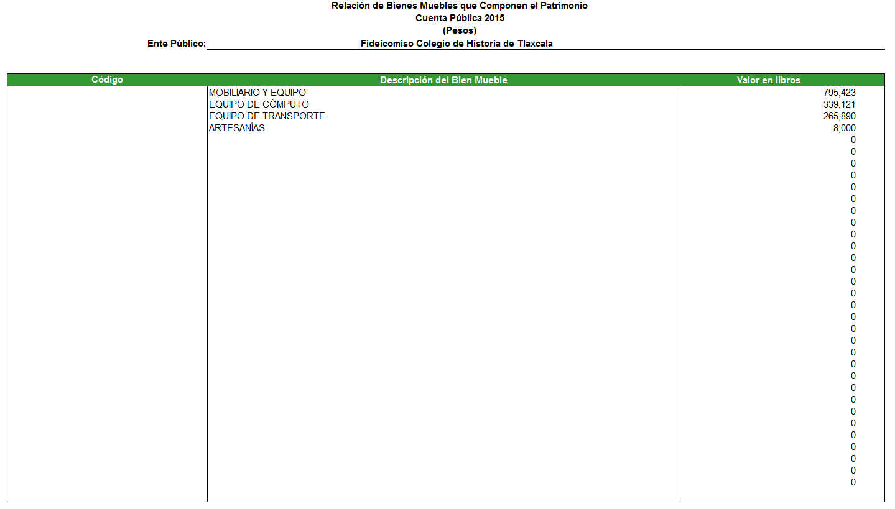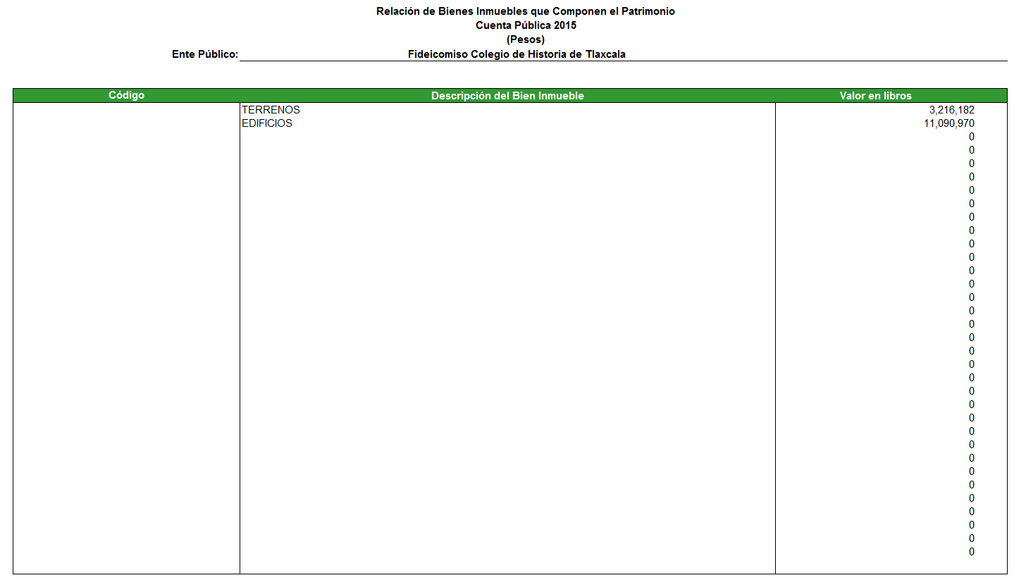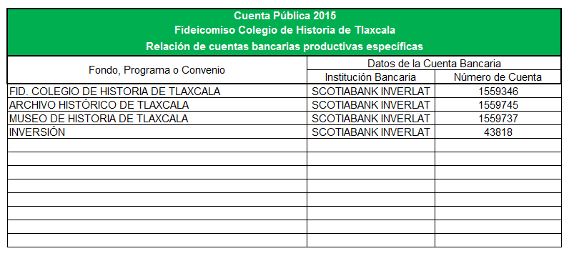

Relación de esquemas bursátiles y de coberturas financieras

No aplica

|  |  |
| --- | --- |
| _________________________________________ | _________________________________________ |
| Antrop. Yolanda Ramos Galicia | Lic. Josefina Sánchez Jiménez |
| Directora General | Departamento Administrativo |

Liga del Gobierno del Estado de Tlaxcala

<http://historia.gob.mx>

|  |  |
| --- | --- |
| _________________________________________ | _________________________________________ |
| Antrop. Yolanda Ramos Galicia | Lic. Josefina Sánchez Jiménez |
| Directora General | Departamento Administrativo |